**Week 1**

Research aims in words:

Hypothesis 1: the use of anti-hypertensive medication (BPMEDS) has impact on the risk of death.

Hypothesis 2: the use of anti-hypertensive medication (BPMEDS) can decrease the risk of death.

Research aims in notation:

Exposure:

$$BPMEDS=\left\{\begin{aligned}1, anti-hypertensive medication is currently used \\ 0, anti-hypertensive medication is not currently used \end{aligned}\right.$$

Outcome:

$DEATH(1)$: potential survival outcome if anti-hypertensive medication is currently used on participant

$DEATH(0)$: potential survival outcome if anti-hypertensive medication is not currently used on participant

We need to solve $E\left(DEATH\left(1\right)\right)-E\left(DEATH\left(0\right)\right)$

**Week 2**

Structure:

• Introduction: research question (0.5p)

• Methods (1p)

• Results (2p)

• Conclusion (1p)

Protocol:

1. Eligibility criteria

Participants in the community of Framingham who are examined biennially after inclusion in the study and continuously followed through regular surveillance for cardiovascular outcomes

2. Exposure definition

Exposed in study: if participants receive anti-hypertensive medication during first examination period

Non exposed: if participants don’t receive anti-hypertensive medication during first examination period

3. Assignment procedures

Whether receiving anti-hypertensive medication is based on the observed data.

4. Follow-up period

24 years after the participant is included in the study.

5. Outcome definition

Mortality during 24 years

6. Causal contrast of interest

$$E\left(DEATH\left(1\right)\right)-E\left(DEATH\left(0\right)\right)$$

**Week 3**

DAG:

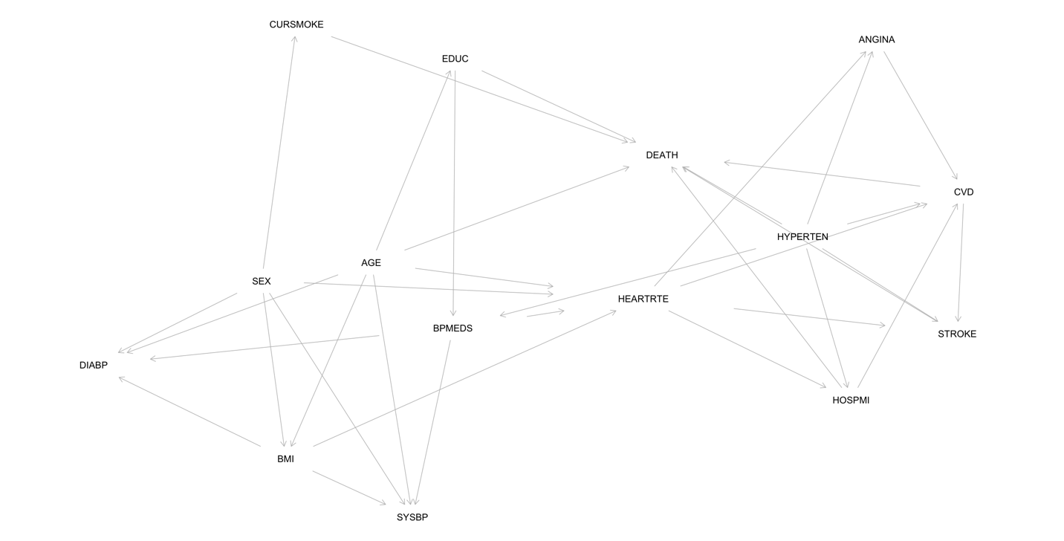

Adjusting set

{EDUC, HYPERTEN}